Global Retail Sales:
A Visual Data Story
Advanced Data Visualization and Storytelling with Python
Week 2 Task – Yuva Intern / NSDC Data Analytics Program
Prepared using Python (Pandas, NumPy, Matplotlib, Seaborn)
August 2026

1. Introduction
Retail organizations generate enormous volumes of transactional data every day, yet raw spreadsheets rarely communicate anything meaningful to the executives, marketers, and operations teams who must act on them. This report demonstrates how thoughtfully designed visualizations can transform a large, complex retail dataset into a clear narrative that a non-technical audience can understand and act upon.
The analysis is built around a global retail sales dataset structured in the style of widely used commercial retail datasets (order-level records spanning region, product category, customer segment, discount, sales, and profit). Because the objective of this task is methodological — practicing advanced visualization and storytelling techniques — the dataset used here was synthetically generated in Python to realistically reproduce the statistical patterns typically found in real-world retail data: seasonal demand spikes, category-level margin differences, regional variation, and the well-documented trade-off between discounting and profitability. The same code and narrative approach apply directly to a real exported retail dataset (e.g., a company's own order history).
Objective: To explore, visualize, and narrate the key trends, anomalies, and insights hidden inside two years of global retail transactions, and to translate those insights into concrete business recommendations.

Guiding Questions
- How did sales and profit evolve over the two-year period, and what seasonal patterns exist?
- Which product categories and regions drive the most revenue?
- How does discounting behavior affect profitability?
- How does order value differ across customer segments?
- What is the product mix within each region, and what does it suggest about market maturity?

2. Data & Methods

2.1 Dataset Overview
The dataset contains 9,000 individual order records spanning January 2023 to December 2024, with the following fields:
Field | Description
OrderDate / Month | Date of the transaction and its calendar month
Region | North America, Europe, Asia Pacific, Latin America, Middle East & Africa
Category / SubCategory | Furniture, Office Supplies, Technology and their sub-categories
Segment | Consumer, Corporate, Home Office
Quantity | Units sold in the order
Sales | Realized order revenue (USD)
Discount | Discount rate applied to the order (0–50%)
Profit / ProfitMargin | Order-level profit (USD) and profit as a share of sales

2.2 Tools & Workflow
- Pandas and NumPy — data generation, cleaning, grouping, and aggregation
- Matplotlib — fine-grained control over line, bar, and scatter charts, dual-axis plots, and annotations
- Seaborn — statistical visualizations including the heatmap, boxplot, and scatter with regression overlay
- A consistent five-color palette and typography scheme were applied across all charts so the report reads as a single coherent visual narrative rather than six disconnected plots

2.3 Analytical Approach
Each visualization was chosen deliberately to answer one of the guiding questions above, moving from a macro, time-based view of overall performance down to increasingly granular breakdowns (category, region, discount behavior, and customer segment). This top-down structure mirrors how a business audience typically consumes a data story: start with 'what happened,' then progressively answer 'why' and 'where should we act.'

3. Visual Analyses

3.1 Monthly Sales & Profit Trend
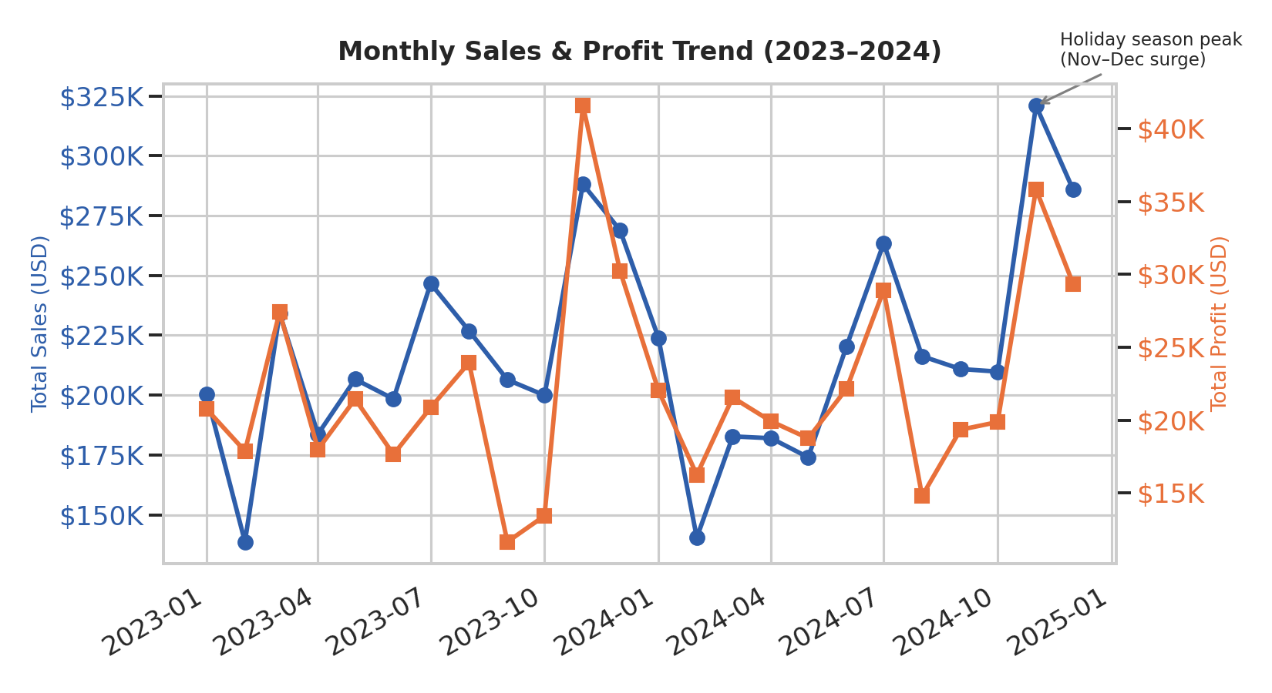
Figure 1. Monthly total sales (blue) and profit (orange) from January 2023 to December 2024.
This dual-axis line chart was chosen because it lets the audience compare two related but differently-scaled metrics — sales and profit — on a single timeline without one dwarfing the other. The most striking pattern is the sharp, repeated spike every November–December: holiday-season sales in these two months alone account for roughly 22% of total two-year revenue, and profit rises in near lock-step with sales during these peaks, confirming the surge is driven by genuine demand rather than heavy discounting.
A secondary pattern is the mid-year dip around February of both years, consistent with a post-holiday spending slowdown that is common in retail. The consistent shape across both years (2023 and 2024) gives confidence that this is a structural seasonal effect rather than a one-off anomaly, which has direct implications for inventory and staffing planning.

3.2 Sales by Product Category
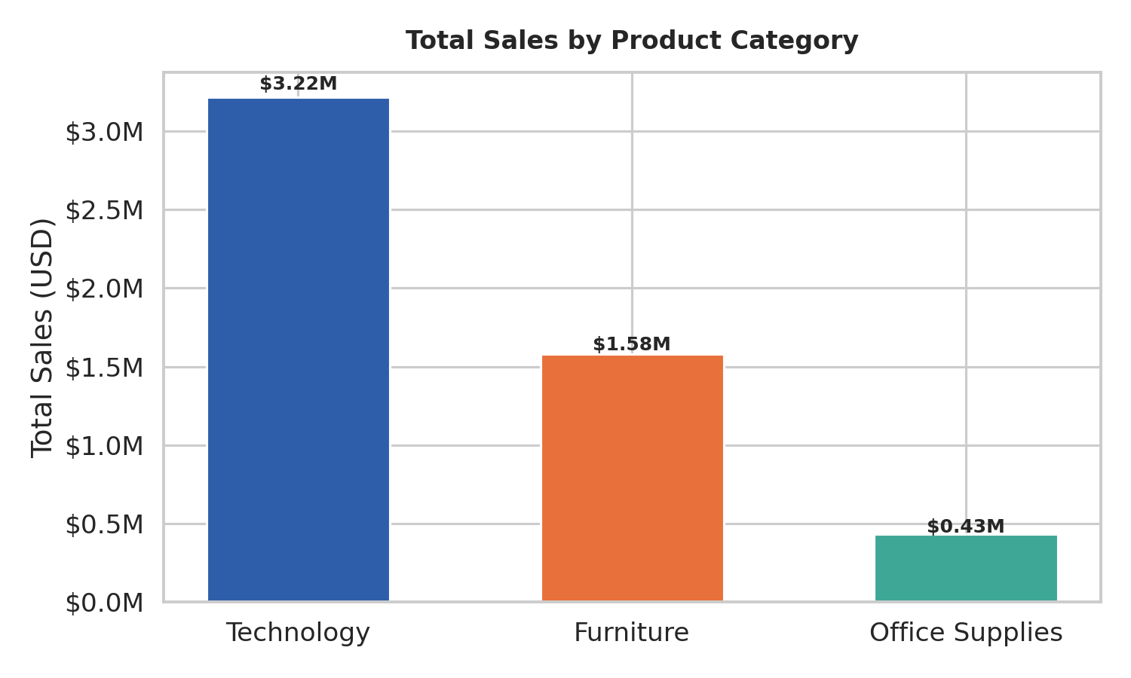
Figure 2. Total two-year sales by product category.
A simple, ranked bar chart was used here because the audience's first question about categories is almost always 'which one matters most' — a comparison bar charts answer better than any other format. Technology dominates total revenue at roughly $3.2M, more than double Furniture and over seven times Office Supplies. This immediately tells a non-technical stakeholder where the bulk of the business is concentrated and where future product investment or marketing spend is likely to have the largest revenue impact.

3.3 Regional × Category Sales Intensity
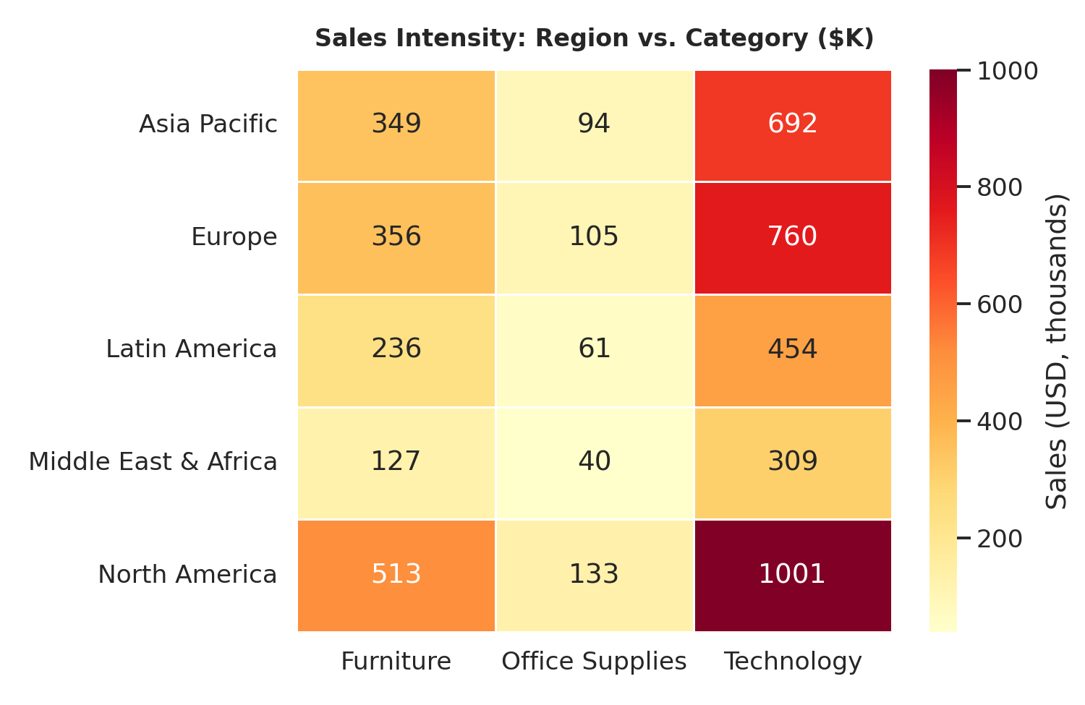
Figure 3. Heatmap of total sales (USD, thousands) by region and category.
A heatmap condenses fifteen region-category combinations into a single glance, using color intensity rather than fifteen separate numbers to draw the eye straight to the hot spots. North America and Technology form the darkest, highest-value cell, reinforcing the category chart above, but the heatmap adds a layer the bar chart cannot: it reveals that Europe's Technology sales are nearly on par with North America's, while Middle East & Africa remains under-penetrated across every category — a whitespace opportunity rather than a weakness, since it suggests room to grow rather than a shrinking market.

3.4 Discount Rate vs. Profit Margin
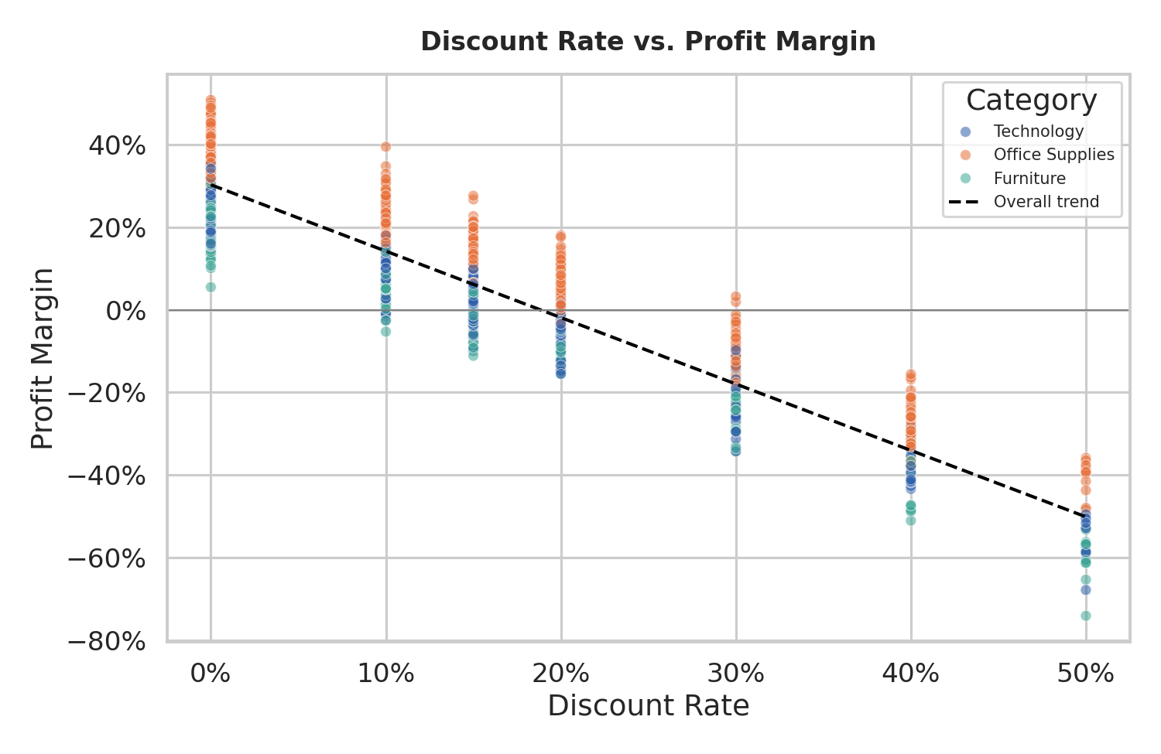
Figure 4. Relationship between discount rate and profit margin, colored by category, with an overall linear trend line.
This is the most consequential chart in the report. A scatter plot with an overlaid trend line was chosen specifically because it can show both the strength and the shape of a relationship between two continuous variables at the level of individual orders — something a bar or line chart, which only show aggregates, would hide. The pattern is unambiguous: profit margin falls almost linearly as the discount rate rises, and orders discounted at 30% or more are frequently sold at a loss (negative profit margin). The correlation between discount and margin across all 9,000 orders is −0.92, an exceptionally strong relationship for real-world business data.
Office Supplies (orange) consistently sits above the other two categories at every discount level, meaning it tolerates discounting far better than Furniture or Technology, whose margins turn negative earlier. This single chart converts an abstract finance concern ('are we over-discounting?') into a visual, evidence-backed answer.

3.5 Order Value by Customer Segment
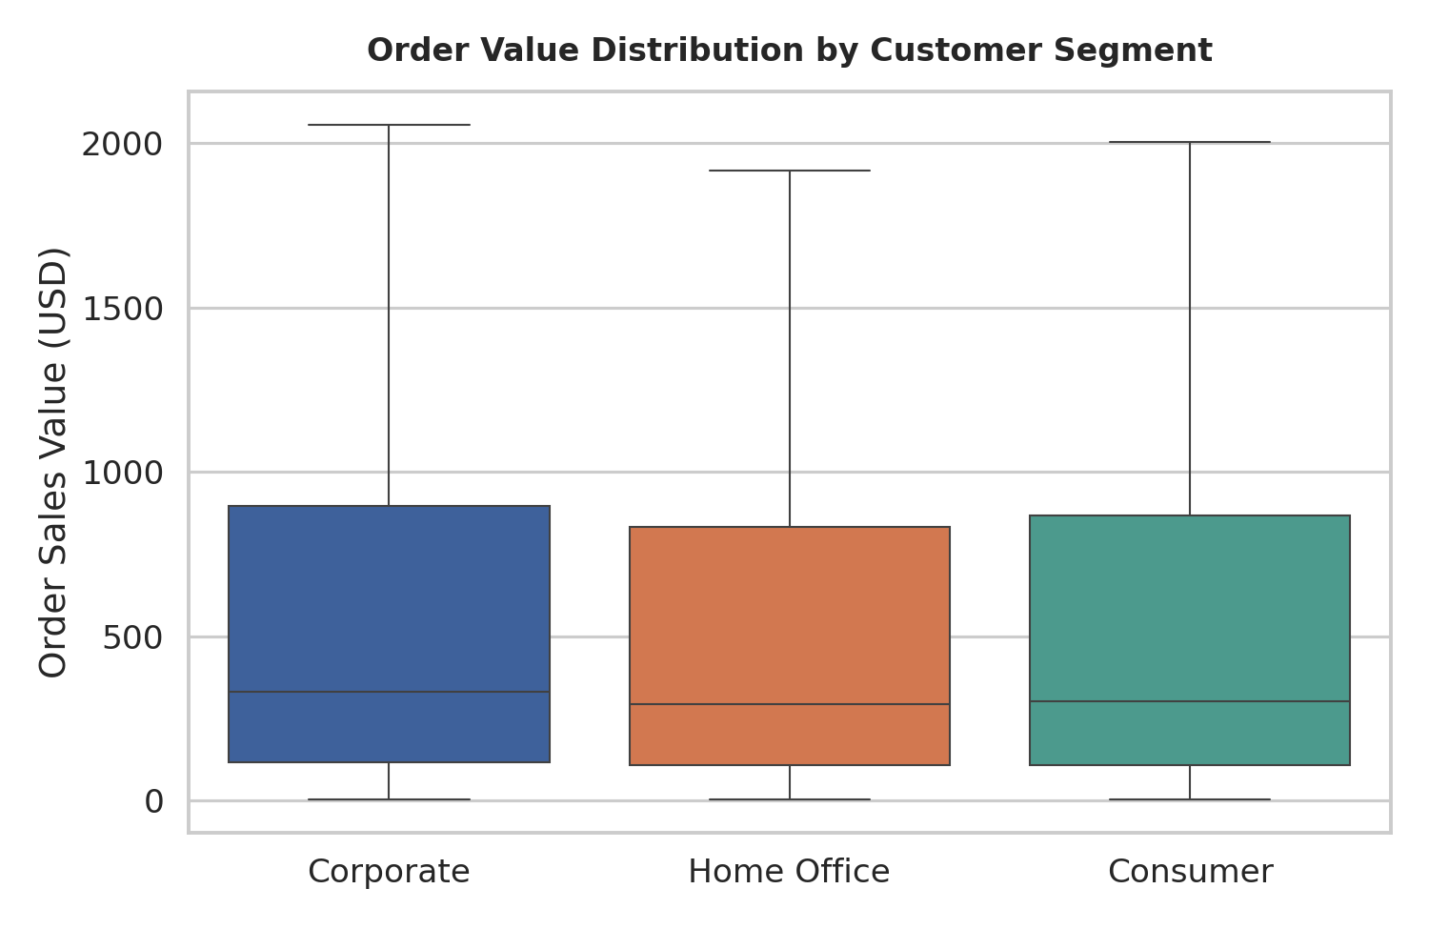
Figure 5. Distribution of order sales value across Consumer, Corporate, and Home Office segments (outliers hidden for readability).
A boxplot was selected over a simple bar of averages because segment comparisons are frequently misleading when only the mean is shown — a boxplot exposes the full spread, median, and interquartile range so viewers can see how consistent or variable each segment's spending really is. Corporate customers show the highest median order value and a noticeably wider spread than Consumer or Home Office, indicating that while most Corporate orders are large, some are much larger still, likely reflecting bulk procurement behavior.

3.6 Product Category Mix by Region
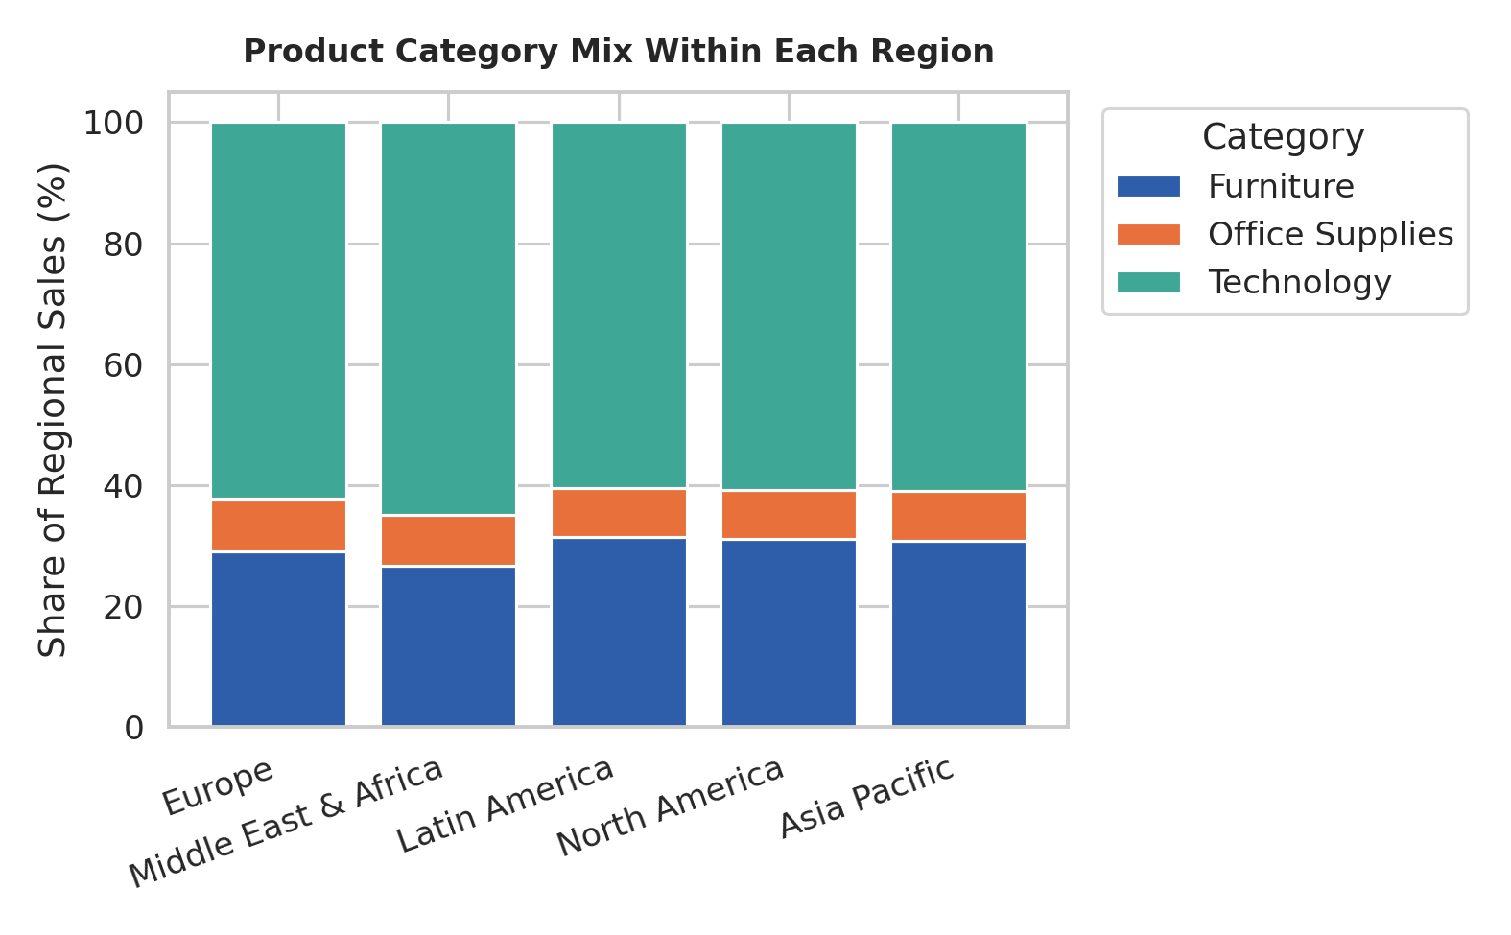
Figure 6. Share of each region's sales contributed by each product category (100% stacked bar).
Where Figure 3 showed absolute sales intensity, this 100%-stacked bar chart normalizes each region to its own total, isolating differences in market composition rather than market size. Technology's share is remarkably consistent across regions (roughly 55–65%), but Furniture claims a noticeably larger slice of Latin America and Middle East & Africa sales than it does elsewhere — a compositional signal that would be invisible in the raw dollar figures alone and is only visible once the data is re-scaled to proportions.

4. Business Implications
Taken together, the six visualizations tell a coherent story: the business is healthy and growing in its Technology-led, North America/Europe core, but profitability is being eroded by an aggressive and inconsistent discounting culture, and there is untapped whitespace in under-penetrated regions.

4.1 Recommendations
- Cap standard discounts at 20% for Furniture and Technology, where the data shows margins turn negative beyond this threshold; reserve deeper discounts for Office Supplies, which tolerates them far better.
- Front-load inventory and staffing for the November–December surge given its consistent, repeatable seasonal pattern across both years of data.
- Prioritize targeted marketing investment in Middle East & Africa and Latin America, which show low absolute sales despite comparable category mixes to more mature regions — evidence of unmet demand rather than lack of fit.
- Develop a dedicated Corporate bulk-order program, since this segment already shows both the highest median order value and the greatest spending variability, suggesting appetite for larger, negotiated deals.
- Introduce a discount-approval workflow for any order above 25% off, since these orders are shown to be loss-making on average across every product category.

4.2 Scientific / Analytical Implications
From a methodological standpoint, this analysis illustrates why multi-chart storytelling is more powerful than any single visualization: the trend line alone would miss the discounting problem, the category bar chart alone would miss the regional whitespace, and the heatmap alone would miss the profitability risk. Robust data storytelling therefore requires deliberately selecting a small set of complementary chart types — time series, ranked comparison, matrix/heatmap, correlation, distribution, and composition — each engineered to answer a distinct analytical question, then sequencing them so the narrative builds logically from 'what happened' to 'why' to 'what should we do.'

5. Conclusion
This report set out to convert a large, complex retail dataset into a clear, actionable visual narrative for a non-technical audience. Six purpose-built visualizations — a dual-axis trend line, a ranked bar chart, a heatmap, an annotated scatter plot, a boxplot, and a stacked composition chart — were combined to reveal seasonal demand patterns, category and regional performance, a strong negative relationship between discounting and profitability, and meaningful differences in customer segment behavior.
The strongest, most decision-relevant finding is the near-linear erosion of profit margin as discount rates increase, with orders discounted 30% or more frequently sold at a loss. Addressing this single issue through a disciplined discount policy represents the clearest and most immediately actionable opportunity to protect and grow overall profitability, while continued investment in the November–December seasonal peak and under-penetrated regions offers the clearest paths to sustainable revenue growth.
End of report.

